A Complete Guideline to Create a Larval Project

Step - 1

Install XAMPP for MySQL

Download link - <https://www.apachefriends.org/index.html>

Installation video - <https://www.youtube.com/watch?v=h6DEDm7C37A>

Step - 2

InstallLaravelComposer

Download link -<https://getcomposer.org/download/>

Installation video - <https://www.youtube.com/watch?v=BGyuKpfMB9E>

Step – 3

Steps to create a Laravel project by using the Composer. (Link - <https://laravel.com/docs/5.8>)

1. Open Cmd.
2. Laravel Installer(for the first time only)

composer global require laravel/installer

1. Create new Project

Laravel new project

Bangla tutorial link - <https://bit.ly/2GOi1hr>

Step – 4

Now, open your project with a sophisticated editor. (For example with sublime text)

Step -5

Start the Laravel development server

Php artisan serve

Then open your browser with the corresponding link in cmd

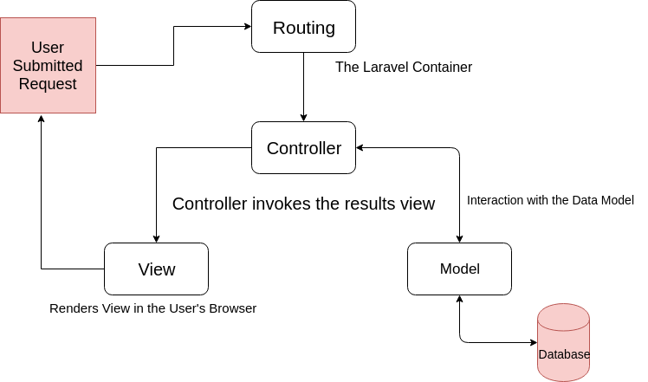

Step – 6

Model:

In MVC model, we have to access database through models. Model acts as an interface between database and controller.

Unfortunately, to fulfill the objective of our Database sessional we have to avoid models and directly access the database from Control with raw SQL cmd.

Views:

Views are nothing but web pages written in php.

Open - resources/views

To open a new view file just create a new file with an extension of **filename.blade.php**

Routes:

Routes are used to forward a user url request to a controller.

Open – routes/web.php

Step -7

Link - https://bit.ly/2XTqwgV

Controllers:

Controller will create a response for the user request with the help of model.

Open - App/ HTTP/controllers

To create a new controller create a new cmd windows a go back to project location.

Php artisan make:controller pageController

Now, write a public function in page controller

public function index()

{

return view('welcome');

}

Change the route for “/” inweb.php file

Route::get('/', 'pagecontroller@index');

Step – 8 (Database Connection)

Open the .env file and edit the database, username, and password.

DB_CONNECTION=mysql

DB_HOST=127.0.0.1

DB_PORT=3306

DB_DATABASE=**project**

DB_USERNAME=root

DB_PASSWORD=

Step -9

use Illuminate\Support\Facades\DB;

$users = DB::select('select id from users');

foreach ($users as $user) {

echo $user->id;

}